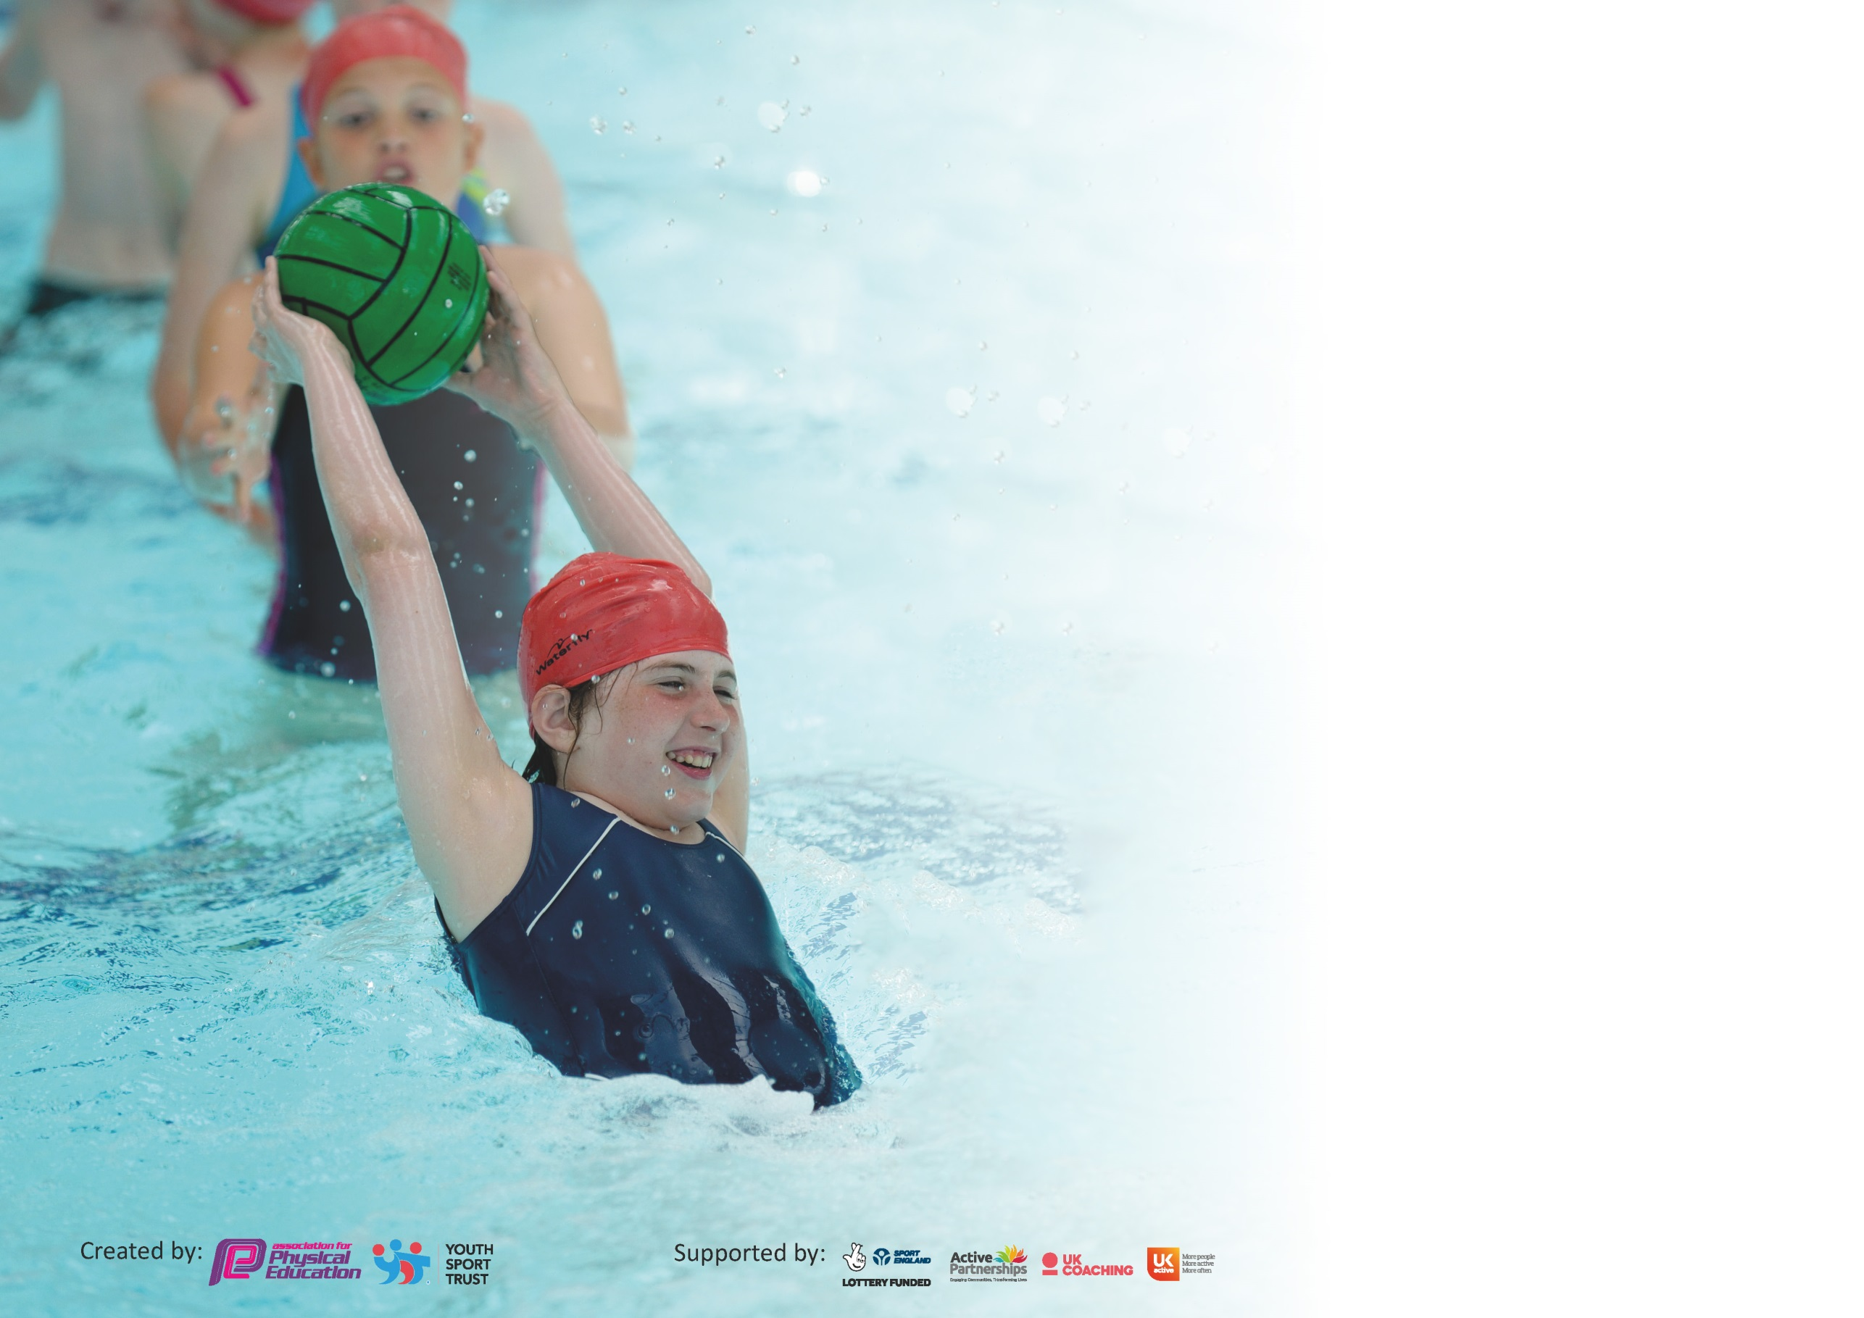

It is important that your grant is used effectively and based on school need. The Education Inspection Framework (Ofsted 2019 p64) makes clear there will be a focus on ‘whether leaders and those responsible for governors all understand their respective roles and perform these in a way that enhances the effectiveness of the school’.

Under the Quality of Education criteria (p41) inspectors consider the extent to which schools can articulate their curriculum (INTENT), construct their curriculum (IMPLEMENTATION) and demonstrate the outcomes which result (IMPACT).

To assist schools with common transferable language this template has been developed to utilise the same three headings which should make your plans easily transferable between working documents.

Schools must use the funding to make additional and sustainable improvements to the quality of Physical Education, School Sport and Physical Activity (PESSPA) they offer. This means that you should
use the Primary PE and Sport Premium to:

- Develop or add to the PESSPA activities that your school already offer
- Build capacity and capability within the school to ensure that improvements made now will benefit pupils joining the school in future years

Please visit gov.uk for the revised DfE guidance including the 5 key indicators across which schools should demonstrate an improvement. This document will help you to review your provision and to report your spend. DfE encourages schools to use this template as an effective way of meeting the reporting requirements of the Primary PE and Sport Premium.

We recommend you start by reflecting on the impact of current provision and reviewing the previous spend.

Schools are required to publish details of how they spend this funding as well as on the impact it has on pupils’ PE and sport participation and attainment by the end of the summer term or by 31st July 2020 at the latest.

We recommend regularly updating the table and publishing it on your website throughout the year. This evidences your ongoing self-evaluation of how you are using the funding to secure maximum, sustainable impact. Final copy must be posted on your website by the end of the academic year and no later than the 31st July 2020. To see an example of how to complete the table please click HERE.

Support for review and reflection - considering the 5 key indicators from DfE, what development needs are a priority for your setting and your pupils now and why? Use the space below to reflect on previous spend and key achievements and areas for development.

Key achievements to date until July 2019: | Areas for further improvement and baseline evidence of need:
Daily Mile to be reintroduced to school, to help to keep children active and healthy Sports and healthy living week in Summer 2019  Promoted links with local sports clubs via weekly newsletter and via PE notice board in hall. | Encourage other KS1 and then KS2 classes to take part in Daily Mile.  Introduce craze of the week.  Sports Ambassadors and Sports Leaders to be trained and support staff and pupils at lunchtimes and for special sporting events.  Staff upskilled through being trained by sports coach and yoga teacher  Timetable sports fairs and festivals into each class’ agenda for the coming year (2019-2020) to ensure all classes access at least one inter and intra school activity for the year (plus the annual sports days)

Meeting national curriculum requirements for swimming and water safety.
What percentage of your current Year 6 cohort swim competently, confidently and proficiently over a distance of at least 25 metres?  N.B. Even though your pupils may swim in another year please report on their attainment on leaving  primary school at the end of the summer term 2020. | 95%
What percentage of your current Year 6 cohort use a range of strokes effectively [for example, front crawl, backstroke and breaststroke]? | 95%
What percentage of your current Year 6 cohort perform safe self-rescue in different water-based situations? | 95%
Schools can choose to use the Primary PE and Sport Premium to provide additional provision for swimming but this must be for activity over and above the national curriculum requirements. Have you used it in this way? | Yes/No

Action Plan and Budget Tracking
Capture your intended annual spend against the 5 key indicators. Clarify the success criteria and evidence of impact that you intend to measure to evaluate for pupils today and for the future.

Academic Year: 2019/20 | Total fund allocated: £17440 | Date Updated: 13/07/20
Key indicator 1: The engagement of all pupils in regular physical activity – Chief Medical Officer guidelines recommend that primary school pupils undertake at least 30 minutes of physical activity a day in school |  |  |  | Percentage of total allocation:
 |  |  |  | 6%
Intent | Implementation |  | Impact
Your school focus should be clear what you want the pupils to know and be able to do and about  what they need to learn and to  consolidate through practice: | Make sure your actions to achieve are linked to your intentions: | Funding allocated: | Evidence of impact: what do pupils now know and what can they now do? What has changed?: | Sustainability and suggested next steps:
Introduce craze of the week to the school in order for children to have opportunities for activity at lunchtimes.  Outside coaches to provide sport before school at lunchtimes and after school.  Daily Mile – all teachers to take children outside for daily mile | Audit physical activity  during the school day via  each class’s curriculum  timetables.  Purchase equipment to be  used during play and  lunchtimes to increase  physical activity: Craze of the Week introduced at beginning of year.  Coaches to run clubs during  play and lunchtimes;  basketball, running club, netball club and football club. | £1000 | - Feedback from pupils,  - Involvement of children taking part in sports  This has been valuable to see which children are engaged in activities.  Children engaged in activities at lunchtime. This has been excellent for developing team building and engaging children in different activities.  - Club registers  - List of clubs  - Calendar of sporting events  Clubs have been really effective and there has been good uptake of the different sports. | To further monitor the participation of individual children. To engage them in new sports that are being introduced in lessons.
Key indicator 2: The profile of PESSPA being raised across the school as a tool for whole school improvement |  |  |  | Percentage of total allocation:
 |  |  |  | 6%
Intent | Implementation |  | Impact
Your school focus should be clear what you want the pupils to know and be able to do and about  what they need to learn and to  consolidate through practice: | Make sure your actions to achieve are linked to your intentions: | Funding allocated: | Evidence of impact: what do pupils now know and what can they now do? What has changed?: | Sustainability and suggested next steps:
To raise the profile of PESSPA this  year, we have tried to promote  PESSPA throughout the school site  with activities ie, craze of the week  The focus being to make PESSPA  more prominent throughout school  life and embedding PESSPA into our  school day. The intended impact is for children to feel like PESSPA is a  normal, regular part of daily life  during school but also outside of the  school day.  Year 6 children apply to become Sports Ambassadors by writing to PE Lead.  Ensure that all children have correct PE equipment to enable them to participate in all sporting activities  Sports Week – 22nd-26th June 2020 | Sports Ambassadors applied to become SA. PE Lead chose children where is was evident of children’s interest in sport and their ability to be committed and represent the school.  Sports leader and sports  ambassadors badges for children  in these roles.  Year 5 teacher to train sports leaders in craze of the week activities.  Sports Ambassadors to attend School Council meetings once a month to discuss whole school sports events (PE Lead also School Council Lead).  Sports Ambassadors to meet once a fortnight with PE Lead.  Sports Ambassadors to oversee Sports Leaders and craze of the week.  Sports Ambassadors and Sports Leaders will support KS2 lead to prepare for key stage sports afternoon and the provision of sports day.  Any disadvantaged child without a PE kit will be provided with one. | £1020 | This years Sports Ambassadors were keen to serve the school and took on the responsibility of their position. They came up with some fantastic ideas which we planned to implement, but has to cancel due to Covid-19.  The Year 4 teacher had planned to train the sports leaders in the summer term. This did not occur due to Covid-19.  The craze of the week was introduced this year and was very successful. Sports Leaders took responsibility for their roles  Event cancelled due to Covid-19  This has resulted in disadvantaged children being able to participate in all sports in school and to attend PE competitions  Due to Covid-19, this was an online week of activities | Continue with Sports Ambassadors and Sports Leaders to raise the profile of PESSPA in school.  Continue with craze of the week and lunchtime activities.

Key indicator 3: Increased confidence, knowledge and skills of all staff in teaching PE and sport |  |  |  | Percentage of total allocation:
 |  |  |  | 57%
Intent | Implementation |  | Impact
Your school focus should be clear | Make sure your actions to | Funding | Evidence of impact: what do | Sustainability and suggested
what you want the pupils to know | achieve are linked to your | allocated: | pupils now know and what | next steps:
and be able to do and about | intentions: |  | can they now do? What has
what they need to learn and to |  |  | changed?:
consolidate through practice:
To develop staff confidence, knowledge and skills through CPD and an update of resources which enable staff to have up to date, interactive PE lessons that are high quality.  In order to improve progress and achievement of all pupils the focus over the next two years is on up-skilling the staff  PE Coach and Yoga teacher to be employed | Sports coach to train staff to give them confidence to teach next year.  PE Lead to audit staff. | £9873 | It is evident that, children progress through the school that they understand the value of PE and remember the rules of sports from the previous years learning. The consolidation of repeating sports has enabled the PE Lead SLT to monitor the individual development of each child and overall impact on the school. | Next steps is to purchase a scheme of work for teachers to continue to teach a high level of sports provision to every class. This will include active breaks and lunchtime activities.  PE Lead to audit staff and make sure that all staff are confident and trained to maintain the high level of provision that the children have received.  New sports will be introduced next year. The PE Lead will monitor the teaching of PE and observe class teachers and also meet with pupils once a term for feedback on the development and enjoyment of PE across the school.
Key indicator 4: Broader experience of a range of sports and activities offered to all pupils |  |  |  | Percentage of total allocation:
 |  |  |  | 5%
Intent | Implementation |  | Impact
Your school focus should be clear | Make sure your actions to | Funding | Evidence of impact: what do | Sustainability and suggested
what you want the pupils to know | achieve are linked to your | allocated: | pupils now know and what | next steps:
and be able to do and about | intentions: |  | can they now do? What has
what they need to learn and to |  |  | changed?:
consolidate through practice:
To use pupil voice to purchase  equipment for sports that children  would like to try and have on the  curriculum as well as during  enrichment times. The idea is to  deliver a broad range of new  activities during curriculum time,  school sports and physical activity  times. This would ensure children get  to try many different sports and  further foster a love for PESSPA. This  would help embed PESSPA into daily  school life and increase the chances  of every child finding a sport that  they really connect with. This would  then benefit each child by helping  them to maximise their potential and  lead a healthy active lifestyle.  This includes being part of the DSSN.  Yoga introduced to all year groups to impact on children’s mental health. | Rocktopus attended the school and involved each year group. Children participated in different activities and created songs for PE sessions.  PE Lead to meet with children | £900 | Children engaged in learning new songs and were enthusiastic.  - Invoices of equipment bought  New resources enabled children to have craze of the week and more playground activities. | Two outdoor table tennis tables have been ordered and equipment is in place for children to participate at lunchtimes. £1400  8% of SP  New scheme of work with new sports to be introduced.  All teachers to use the Rocktopus music during PE lessons.

Key indicator 5: Increased participation in competitive sport |  |  |  | Percentage of total allocation:
 |  |  |  | 5%
Intent | Implementation |  | Impact
Your school focus should be clear | Make sure your actions to | Funding | Evidence of impact: what do | Sustainability and suggested
what you want the pupils to know | achieve are linked to your | allocated: | pupils now know and what | next steps:
and be able to do and about | intentions: |  | can they now do? What has
what they need to learn and to |  |  | changed?:
consolidate through practice:
To continue subscribing to DSSN and  attending competitions throughout the year. We have tried to take as many teams as possible to events and in some cases whole classes to try to  increase the amount of children taking part in competitive sports. | Purchase DSSN  Membership  Relevant staff to attend competitive opportunities with pupils (and staff to cover classes in school where required) Where PE Lead attends with other classes, PE Lead class to be covered. | £930 | - Photos  - School website  - Newsletters  The DSSN membership has  allowed all children to be offered  opportunities to participate in  competitive sport. The impact of  this is that a high percentage of  children have undertaken  competitive sports this year at  St Thomas More. In a majority of cases, the whole class has taken part in an event. This has ensured more children get selected to take part in competitive sports.  Competitions competed in so far this year (Sept-Mar) as a result of being part of the School Sports Partnership.  -Yr 3/4 Cross Country  -Yr 5/6 Cross Country  -Yr 1 Interschool festivals  -Yr 3/4 football festivals  -Yr 2 Indoor Athletics  -Y2 Sports Festival  -Yr 2 Target Games  -Yr 4 Rapid Fire Cricket  -Yr 4 Speedstacking  -Yr 6 Dodgeball  All other events were | The DSSN membership will  continue again next year.  Next, we will look to purchase equipment that will enable us to participate in sports more competitively such as boccia and dodgeball equipment.  We are also introducing more sports into the curriculum to give children a wider experience of sports and to enable each child to find a sport that they connect with. This will include hockey, netball, OAA, team building and cricket.  To keep costs down, the PE Lead will make sure that  sporting events are within walking distance where whole  classes can attend to ensure  more children take part in  competitive sports.

Signed off by
Head Teacher:
Date: | 30/7/20
Subject Leader:
Date: | 30/7/20
Governor:
Date:

